WEEK – 1

Financial Forecasting

Nipuna Amanapu

[namanapu@gitam.in](mailto:namanapu@gitam.in)

superset id : 6432842

**Exercise 7: Financial Forecasting**

**Scenario:**

You are developing a financial forecasting tool that predicts future values based on past data.

**Steps:**

1. **Understand Recursive Algorithms:**
   * Explain the concept of recursion and how it can simplify certain problems.
2. **Setup:**
   * Create a method to calculate the future value using a recursive approach.
3. **Implementation:**
   * Implement a recursive algorithm to predict future values based on past growth rates.
4. **Analysis:**
   * Discuss the time complexity of your recursive algorithm.
   * Explain how to optimize the recursive solution to avoid excessive computation.

Solution :

1. Forecast.java

public class Forecast {

public static double futureValue(double principal, double rate, int years) {

if (years == 0) {

return principal;

}

return futureValue(principal * (1 + rate), rate, years - 1);

}

public static void main(String[] args) {

double principal = 1000.0;

double rate = 0.10;

int years = 5;

double result = futureValue(principal, rate, years);

System.out.printf("Future Value after %d years: %.2f\n", years, result);

}

}

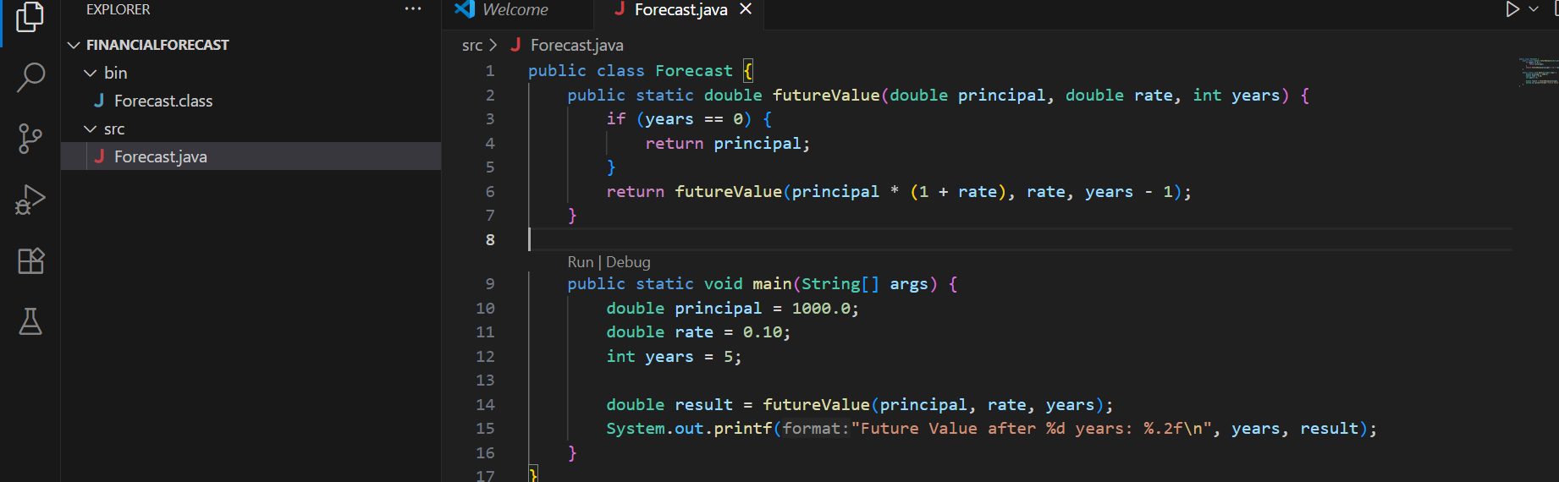

Output:

